[1]

Scion IoT Smart Home – Smart Smoke Detector

First A. Author, *Fellow, IEEE*, Second B. Author, and Third C. Author, Jr., Member, IEEE

*Abstract*- Internet of things is an evolutionary idea which connects different physical things to the internet. It has huge business opportunity in the regards of home automation, as we become more automated on every other sector. It would be essential for our future to adapt IoT in to the building sector. When considering our homes, providing the household equipment’s the ability to communicate each other, will make it more secure and smarter. Through this project our goal is to design a smart device for smoke detection at home. A smoke detector makes use of different sensors in order to detect a smoke. We have a Raspberry pi with scion server installed on it as a central controlling device, also we have used an ESP module for establishing the communication between the smoke detector and Raspberry Pi. According to the data received from the smoke detector the ESP module will determine whether it is a test alarm or a genuine one, and the whole setup will be constantly in communication with other smart devices and will be monitored by a controlled local machine.

*Index Terms*—Enter key words or phrases in alphabetical order, separated by commas. For a list of suggested keywords, send a blank e-mail to [keywords@ieee.org](mailto:keywords@ieee.org) or visit <http://www.ieee.org/organizations/pubs/ani_prod/keywrd98.txt>

# INTRODUCTION

T

he project objective is to develop a smarter smoke detector by enhancing a conventional photo electric smoke detector available in the market. The normal smoke detectors don’t have the functionality to instantly inform you about the danger if you are not at the specific place. So, in a smart home environment our task is to identify whether the detector is indicating the actual smoke or a simple test alarm and also to inform about the situation to the customer instantly. The project has two ends, one server end which has the Raspberry Pi and on other end, an ESP 8266 module is attached to the smoke detector. The ESP 8266 module is Wi-Fi based low-cost microchip, which is used to avoid the wired connection between the Raspberry Pi and the Smoke detector. The ESP 8266 module will transmit the data received from smoke detector to the Raspberry Pi through the Wi-Fi. Additionally, the ESP 8266 and the smoke detector would made in to a single compact product “Smart Smoke Detector”, so it would be more beneficial for the households to use the developed system instead of conventional smoke detectors. Moreover, a Graphical User Interface (GUI) using Node-Red (a Flow based GUI tool) is developed to visualize the readings from the smoke detector.

# Literature Survey

In the scope of this project, the initial goal is to gain enough knowledge about the working of smoke detectors and Microchip modules. The smoke detector used in this project is a normal photo electric smoke detector. These detectors make use of light to detect the fire. Inside the detector, there is a light-sensing chamber. In this chamber, a LED projects light in a straight line, when smoke enters this chamber it cuts the LED straight line inside the chamber which rings the alarm. The whole process is controlled by an IC- MC 146010.

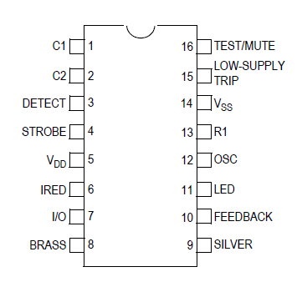

Figure 1. Pin Diagram of MC 146010

The MC 146010 IC has 16 pins, each one has its own purpose. For this project, the I/O pin is read continuously to ensure whether a smoke is detected or not. When a smoke is detected or tested the I/O pin gives a high output signal.

The ESP8266 is used for the communication part, which is a cheap Wi-Fi based microchip. The ESP 8266 has two mode of operations -Station and Access Point modes, where Access point mode allows the ESP to create its own network and on the other hand the station mode allows the ESP to connect to a Wi-Fi network.

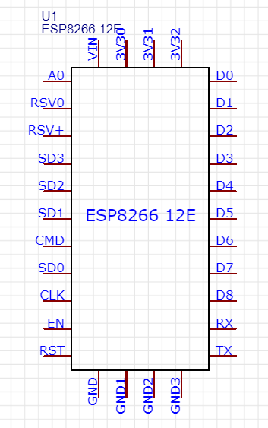

Figure 2. Pinout of ESP 8266

The ESP 8266 uses Wi-Fi for the data transmission, which is highly power consuming in order to tackle with this issue the IC provides different sleeping modes

## Modem Sleep

Modem sleep mode is enabled only when the ESP is setup in Station mode. While in modem sleep mode the ESP will disable the modem with maintaining a Wi-Fi connection. The ESP stays connected to modem through DTIM beacon mechanism. The usual DTIM beacon interval of the modem is 100ms to 1000ms. The modem sleep is usually used in applications where the CPU powered on.

## Light Sleep

The light sleep mode is very similar to the modem sleep mode, the difference is that the ESP will also power off clock and suspends the internal CPU in order to reduce the power consumption in modem sleep mode.

## Deep Sleep

In deep sleep mode the system will turn off everything the only working module would be RTC (Real Time Clock). The deep sleep mode can be activated by connecting the RST pin to D0 pin.

# Circuit Design

This chapter discuss in detail about the project’s circuit design.

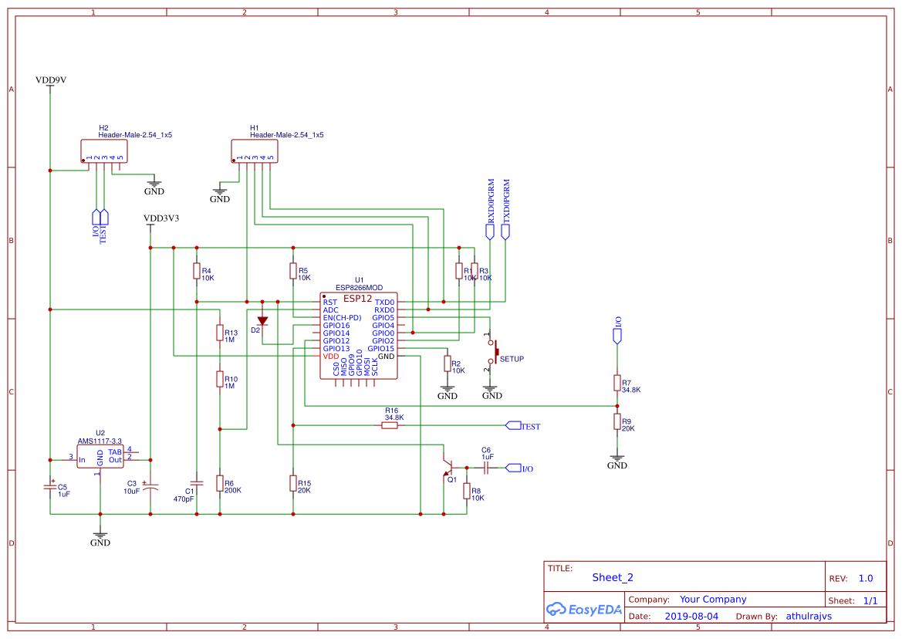

Figure 3. Circuit Diagram

This circuit design can be divided into three integral parts.

## The Circuit setup for Deep Sleep mode

According to the power concerns, deep sleep mode would be the most applicable mode for this project. The deep sleep mode can be achieved by connecting the RST pin to D0 pin. If the ESP 8266 is in deep sleep mode, the D0 pin could not use for any other purposes.

## The circuit setup to get reading from smoke detector

The I/O pin from smoke detector IC is connected to the GPIO 12.

# PCB Design

This chapter discusses about the PCB design.

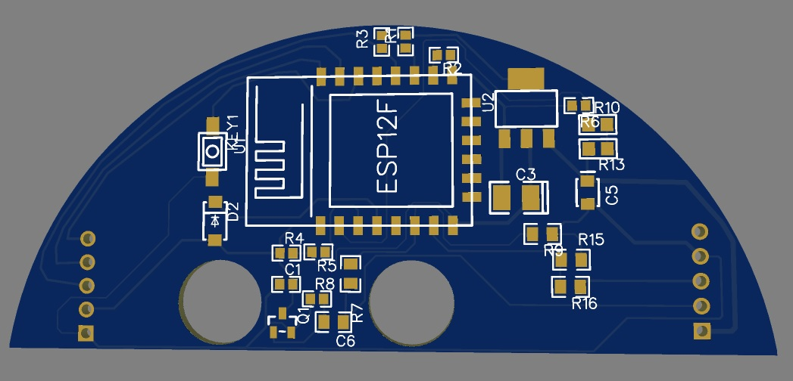

Figure 4. PCB Design

# Wi-Fi Manager

The ESP 8266 has two modes of operations- Station mode and Access Point mode. Initially, when the ESP 8266 is starts up it is configured in Station mode and tries to connect to a Wi-Fi network which is previously saved in ESP 8266. If the ESP8266 is brought up into a new Wi-Fi network, it won’t be connected to the new network. Then it should be made configured in to Access Point mode, so the ESP 8266 will open up a DNS and a webserver. The ESP 8266 then can be connected to the new network by using a Wi-Fi enabled device.

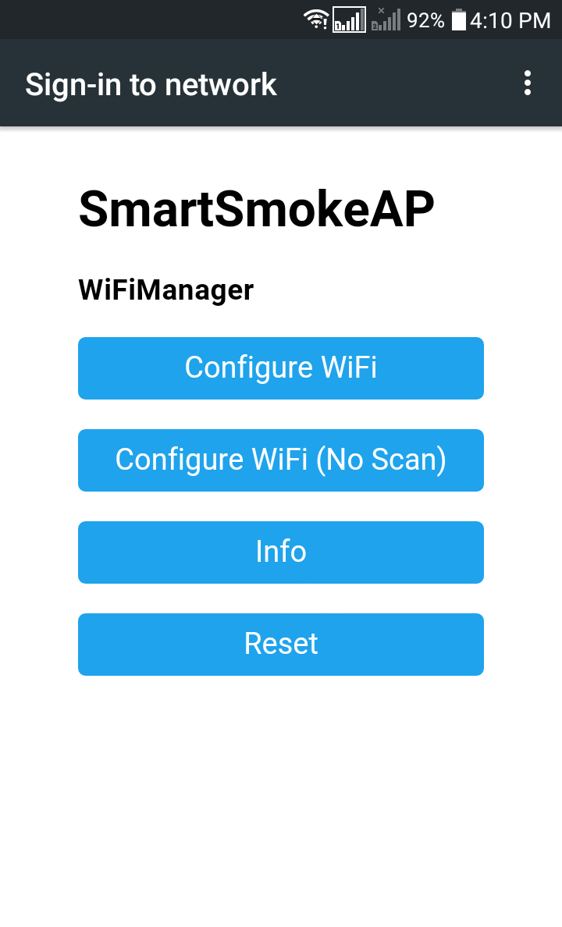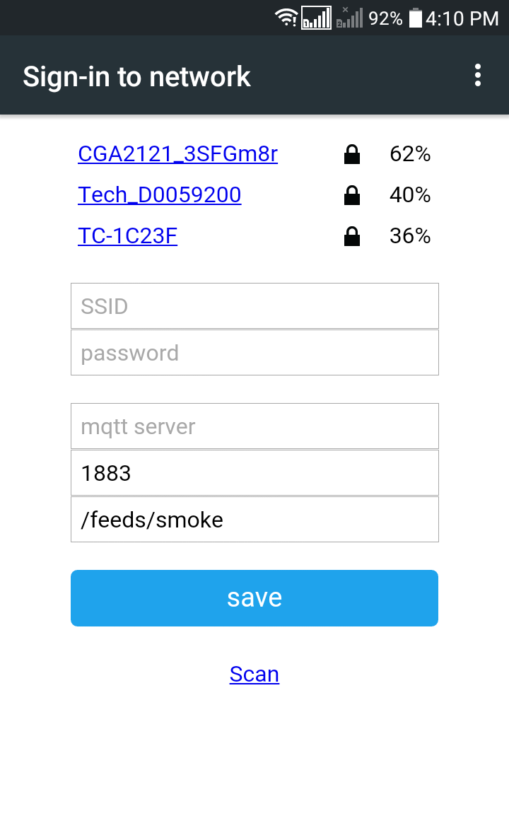

Figure 5. Wi-Fi Configuration

Once the ESP 8266 is connected to a network the credentials would be saved in to the ESP 8266 EPROM. If the module again comes under the same network, it would connect automatically through Station mode of operation.

# Battery Performance Calculation

In this projects scopes, making the whole system in to a stand-alone product had great importance. For that the same battery used in the smoke detector should be use to power the ESP 8266. This has a great concern; the Wi-Fi communication would make the battery to drain quickly. Making the ESP8266 to work on deep sleep mode will reduce the battery drainage and reducing the data transmission would also be beneficial. The ESP will send the data only when there is a smoke is detected or when the smoke is tested. It would also check the battery percentage once in day. According to these operations, the battery consumption for this project could be calculated.

### 

# Code Logic

## The ESP8266 is using the MQTT protocol for the data transmission. So, for the interaction between the Raspberry and the ESP 8266 a MQTT broker/client environment must be setup. The raspberry would be programmed as a MQTT broker. In MQTT protocol the main important participates are Publishers and Subscribers, a broker can act as both Publisher and Subscriber. In this project the ESP 8266 is assigned as a Publisher which will publish a topic and the Raspberry pi as subscriber which would be subscribed in to that topic.

# Node-Red Flow

Node-Red, a flow-based GUI tools based on JavaScript is used to visualize the data received from Smoke Detector. The GUI is developed in a local machine ´which would be useful for the user get information about the current situation.

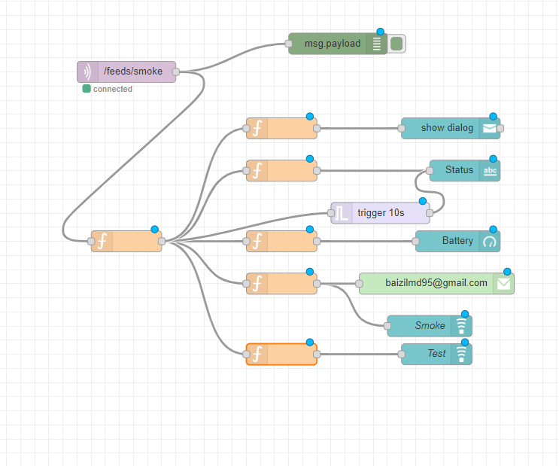

Figure 6. Node-Red Flow

The data from the smoke detector is received through a MQTT- in node. Which is then separated according to the data, each message is displayed in the dashboard. The battery percentage is displayed using a gauge node. When the detector detects smoke, an immediate warning is displayed in the GUI using a notification node along that an Email is sent in to the users mail id through mail node in the node red.

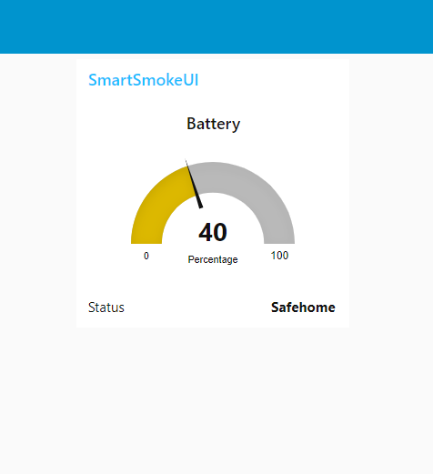 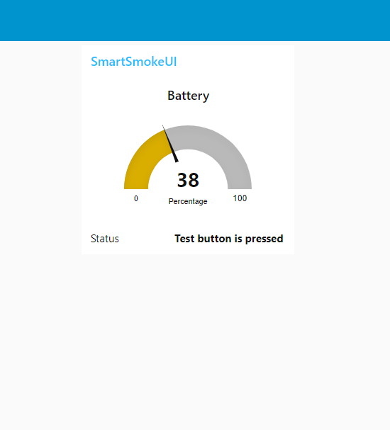

# Conclusion and further works

Appendix

Appendixes, if needed, appear before the acknowledgment.

References

*Basic format for books:*

J. K. Author, “Title of chapter in the book,” in *Title of His Published Book, x*th ed. City of Publisher, (only U.S. State), Country: Abbrev. of Publisher, year, ch. *x*, sec. *x*, pp. *xxx–xxx.*

*Examples:*

1. G. O. Young, “Synthetic structure of industrial plastics,” in *Plastics,* 2nd ed., vol. 3, J. Peters, Ed. New York, NY, USA: McGraw-Hill, 1964, pp. 15–64.
2. W.-K. Chen, *Linear Networks and Systems.* Belmont, CA, USA: Wadsworth, 1993, pp. 123–135.

*Basic format for periodicals:*

J. K. Author, “Name of paper,” *Abbrev. Title of Periodical*, vol. *x, no*. *x,* pp*. xxx-xxx,* Abbrev. Month, year, DOI. 10.1109.*XXX*.123456.

*Examples:*

1. J. U. Duncombe, “Infrared navigation—Part I: An assessment of feasibility,” *IEEE Trans. Electron Devices*, vol. ED-11, no. 1, pp. 34–39, Jan. 1959, 10.1109/TED.2016.2628402.
2. E. P. Wigner, “Theory of traveling-wave optical laser,”   
   *Phys. Rev*.,   
   vol. 134, pp. A635–A646, Dec. 1965.
3. E. H. Miller, “A note on reflector arrays,” *IEEE Trans. Antennas Propagat*., to be published.

*Basic format for reports:*

J. K. Author, “Title of report,” Abbrev. Name of Co., City of Co., Abbrev. State, Country, Rep. *xxx*, year.

*Examples:*

1. E. E. Reber, R. L. Michell, and C. J. Carter, “Oxygen absorption in the earth’s atmosphere,” Aerospace Corp., Los Angeles, CA, USA, Tech. Rep. TR-0200 (4230-46)-3, Nov. 1988.
2. J. H. Davis and J. R. Cogdell, “Calibration program for the 16-foot antenna,” Elect. Eng. Res. Lab., Univ. Texas, Austin, TX, USA, Tech. Memo. NGL-006-69-3, Nov. 15, 1987.

*Basic format for handbooks:*

*Name of Manual/Handbook, x* ed., Abbrev. Name of Co., City of Co., Abbrev. State, Country, year, pp. *xxx-xxx.*

*Examples:*

1. *Transmission Systems for Communications*, 3rd ed., Western Electric Co., Winston-Salem, NC, USA, 1985, pp. 44–60.
2. *Motorola Semiconductor Data Manual*, Motorola Semiconductor Products Inc., Phoenix, AZ, USA, 1989.

*Basic format for books (when available online):*

J. K. Author, “Title of chapter in the book,” in *Title of Published Book*, *x*th ed. City of Publisher, State, Country: Abbrev. of Publisher, year, ch. *x*, sec. *x*, pp. *xxx–xxx*. [Online]. Available: http://www.web.com

*Examples:*

1. G. O. Young, “Synthetic structure of industrial plastics,” in Plastics, vol. 3, Polymers of Hexadromicon, J. Peters, Ed., 2nd ed. New York, NY, USA: McGraw-Hill, 1964, pp. 15-64. [Online]. Available: http://www.bookref.com.
2. *The Founders’ Constitution*, Philip B. Kurland and Ralph Lerner, eds., Chicago, IL, USA: Univ. Chicago Press, 1987. [Online]. Available: http://press-pubs.uchicago.edu/founders/
3. The Terahertz Wave eBook. ZOmega Terahertz Corp., 2014. [Online]. Available: http://dl.z-thz.com/eBook/zomega_ebook_pdf_1206_sr.pdf. Accessed on: May 19, 2014.
4. Philip B. Kurland and Ralph Lerner, eds., *The Founders’ Constitution.* Chicago, IL, USA: Univ. of Chicago Press, 1987, Accessed on: Feb. 28, 2010, [Online] Available: http://press-pubs.uchicago.edu/founders/

*Basic format for journals (when available online):*

J. K. Author, “Name of paper,” *Abbrev. Title of Periodical*, vol. *x*, no. *x*, pp. *xxx-xxx*, Abbrev. Month, year. Accessed on: Month, Day, year, DOI: 10.1109.*XXX*.123456, [Online].

*Examples:*

1. J. S. Turner, “New directions in communications,” *IEEE J. Sel. Areas Commun*., vol. 13, no. 1, pp. 11-23, Jan. 1995.
2. W. P. Risk, G. S. Kino, and H. J. Shaw, “Fiber-optic frequency shifter using a surface acoustic wave incident at an oblique angle,” *Opt. Lett.*, vol. 11, no. 2, pp. 115–117, Feb. 1986.
3. P. Kopyt *et al., “*Electric properties of graphene-based conductive layers from DC up to terahertz range,” *IEEE THz Sci. Technol.,* to be published. DOI: 10.1109/TTHZ.2016.2544142.

*Basic format for papers presented at conferences (when available online):*

J.K. Author. (year, month). Title. presented at abbrev. conference title. [Type of Medium]. Available: site/path/file

*Example:*

1. PROCESS Corporation, Boston, MA, USA. Intranets: Internet technologies deployed behind the firewall for corporate productivity. Presented at INET96 Annual Meeting. [Online]. Available: http://home.process.com/Intranets/wp2.htp

*Basic format for reports and handbooks (when available online):*

J. K. Author. “Title of report,” Company. City, State, Country. Rep. no., (optional: vol./issue), Date. [Online] Available: site/path/file

*Examples:*

1. R. J. Hijmans and J. van Etten, “Raster: Geographic analysis and modeling with raster data,” R Package Version 2.0-12, Jan. 12, 2012. [Online]. Available: http://CRAN.R-project.org/package=raster
2. Teralyzer. Lytera UG, Kirchhain, Germany [Online]. Available: http://www.lytera.de/Terahertz_THz_Spectroscopy.php?id=home, Accessed on: Jun. 5, 2014

*Basic format for computer programs and electronic documents (when available online):*

Legislative body. Number of Congress, Session. (year, month day). *Number of bill or resolution*, *Title*. [Type of medium]. Available: site/path/file

***NOTE:*** ISO recommends that capitalization follow the accepted practice for the language or script in which the information is given.

*Example:*

1. U.S. House. 102nd Congress, 1st Session. (1991, Jan. 11). *H. Con. Res. 1, Sense of the Congress on Approval of Military Action*. [Online]. Available: LEXIS Library: GENFED File: BILLS

*Basic format for patents (when available online):*

Name of the invention, by inventor’s name. (year, month day). Patent Number[Type of medium]. Available: site/path/file

*Example:*

1. Musical toothbrush with mirror, by L.M.R. Brooks. (1992, May 19). Patent D 326 189

[Online]. Available: NEXIS Library: LEXPAT File: DES

*Basic format for conference proceedings (published):*

J. K. Author, “Title of paper,” in *Abbreviated Name of Conf.*, City of Conf., Abbrev. State (if given), Country, year, pp. *xxxxxx.*

*Example:*

1. D. B. Payne and J. R. Stern, “Wavelength-switched pas- sively coupled single-mode optical network,” in *Proc. IOOC-ECOC,* Boston, MA, USA,1985,   
   pp. 585–590.

*Example for papers presented at conferences (unpublished):*

1. D. Ebehard and E. Voges, “Digital single sideband detection for interferometric sensors,” presented at the *2nd Int. Conf. Optical Fiber Sensors,* Stuttgart, Germany, Jan. 2-5, 1984.

*Basic format for patents:*

J. K. Author, “Title of patent,” U.S. Patent *x xxx xxx*, Abbrev. Month, day, year.

*Example:*

1. G. Brandli and M. Dick, “Alternating current fed power supply,” U.S. Patent 4 084 217, Nov. 4, 1978.

*Basic format**for theses (M.S.) and dissertations (Ph.D.):*

a) J. K. Author, “Title of thesis,” M.S. thesis, Abbrev. Dept., Abbrev. Univ., City of Univ., Abbrev. State, year.

b) J. K. Author, “Title of dissertation,” Ph.D. dissertation, Abbrev. Dept., Abbrev. Univ., City of Univ., Abbrev. State, year.

*Examples:*

1. J. O. Williams, “Narrow-band analyzer,” Ph.D. dissertation, Dept. Elect. Eng., Harvard Univ., Cambridge, MA, USA, 1993.
2. N. Kawasaki, “Parametric study of thermal and chemical nonequilibrium nozzle flow,” M.S. thesis, Dept. Electron. Eng., Osaka Univ., Osaka, Japan, 1993.

*Basic format for the most common types of unpublished references:*

a) J. K. Author, private communication, Abbrev. Month, year.

b) J. K. Author, “Title of paper,” unpublished.

c) J. K. Author, “Title of paper,” to be published.

*Examples:*

1. A. Harrison, private communication, May 1995.
2. B. Smith, “An approach to graphs of linear forms,” unpublished.
3. A. Brahms, “Representation error for real numbers in binary computer arithmetic,” IEEE Computer Group Repository, Paper R-67-85.

*Basic formats for standards:*

a) *Title of Standard*, Standard number, date.

b) *Title of Standard*, Standard number, Corporate author, location, date.

*Examples:*

1. IEEE Criteria for Class IE Electric Systems, IEEE Standard 308, 1969.
2. Letter Symbols for Quantities, ANSI Standard Y10.5-1968.

*Article number in reference examples:*

1. R. Fardel, M. Nagel, F. Nuesch, T. Lippert, and A. Wokaun, “Fabrication of organic light emitting diode pixels by laser-assisted forward transfer,” *Appl. Phys. Lett.*, vol. 91, no. 6, Aug. 2007, Art. no. 061103.
2. J. Zhang and N. Tansu, “Optical gain and laser characteristics of InGaN quantum wells on ternary InGaN substrates,” *IEEE Photon. J.*, vol. 5, no. 2, Apr. 2013, Art. no. 2600111

*Example when using et al.:*

1. S. Azodolmolky *et al.*, Experimental demonstration of an impairment aware network planning and operation tool for transparent/translucent optical networks,” *J. Lightw. Technol.*, vol. 29, no. 4, pp. 439–448, Sep. 2011.

**First A. Author** (M’76–SM’81–F’87) and all authors may include biographies. Biographies are often not included in conference-related papers. This author became a Member (M) of IEEE in 1976, a Senior Member (SM) in 1981, and a Fellow (F) in 1987. The first paragraph may contain a place and/or date of birth (list place, then date). Next, the author’s educational background is listed. The degrees should be listed with type of degree in what field, which institution, city, state, and country, and year the degree was earned. The author’s major field of study should be lower-cased.

The second paragraph uses the pronoun of the person (he or she) and not the author’s last name. It lists military and work experience, including summer and fellowship jobs. Job titles are capitalized. The current job must have a location; previous positions may be listed without one. Information concerning previous publications may be included. Try not to list more than three books or published articles. The format for listing publishers of a book within the biography is: title of book (publisher name, year) similar to a reference. Current and previous research interests end the paragraph.

The third paragraph begins with the author’s title and last name (e.g., Dr. Smith, Prof. Jones, Mr. Kajor, Ms. Hunter). List any memberships in professional societies other than the IEEE. Finally, list any awards and work for IEEE committees and publications. If a photograph is provided, it should be of good quality, and professional-looking. Following are two examples of an author’s biography.

**Second B. Author** was born in Greenwich Village, New York, NY, USA in 1977. He received the B.S. and M.S. degrees in aerospace engineering from the University of Virginia, Charlottesville, in 2001 and the Ph.D. degree in mechanical engineering from Drexel University, Philadelphia, PA, in 2008.

From 2001 to 2004, he was a Research Assistant with the Princeton Plasma Physics Laboratory. Since 2009, he has been an Assistant Professor with the Mechanical Engineering Department, Texas A&M University, College Station. He is the author of three books, more than 150 articles, and more than 70 inventions. His research interests include high-pressure and high-density nonthermal plasma discharge processes and applications, microscale plasma discharges, discharges in liquids, spectroscopic diagnostics, plasma propulsion, and innovation plasma applications. He is an Associate Editor of the journal *Earth*, *Moon*, *Planets*, and holds two patents.

Dr. Author was a recipient of the International Association of Geomagnetism and Aeronomy Young Scientist Award for Excellence in 2008, and the IEEE Electromagnetic Compatibility Society Best Symposium Paper Award in 2011.

**Third C. Author, Jr.** (M’87) received the B.S. degree in mechanical engineering from National Chung Cheng University, Chiayi, Taiwan, in 2004 and the M.S. degree in mechanical engineering from National Tsing Hua University, Hsinchu, Taiwan, in 2006. He is currently pursuing the Ph.D. degree in mechanical engineering at Texas A&M University, College Station, TX, USA.

From 2008 to 2009, he was a Research Assistant with the Institute of Physics, Academia Sinica, Tapei, Taiwan. His research interest includes the development of surface processing and biological/medical treatment techniques using nonthermal atmospheric pressure plasmas, fundamental study of plasma sources, and fabrication of micro- or nanostructured surfaces.

Mr. Author’s awards and honors include the Frew Fellowship (Australian Academy of Science), the I. I. Rabi Prize (APS), the European Frequency and Time Forum Award, the Carl Zeiss Research Award, the William F. Meggers Award and the Adolph Lomb Medal (OSA).

1. This paragraph of the first footnote will contain the date on which you submitted your paper for review. It will also contain support information, including sponsor and financial support acknowledgment. For example, “This work was supported in part by the U.S. Depart­ment of Com­merce under Grant BS123456.”

   The next few paragraphs should contain the authors’ current affiliations, including current address and e-mail. For example, F. A. Author is with the National Institute of Standards and Technology, Boulder, CO 80305 USA (e-mail: author@ boulder.nist.gov).

   S. B. Author, Jr., was with Rice University, Houston, TX 77005 USA. He is now with the Department of Physics, Colorado State University, Fort Collins, CO 80523 USA (e-mail: author@lamar.colostate.edu).

   T. C. Author is with the Electrical Engineering Department, University of Colorado, Boulder, CO 80309 USA, on leave from the National Research Institute for Metals, Tsukuba, Japan (e-mail: author@nrim.go.jp).